SEND INFORMATION REPORT 2026–27
Manor Leas Junior Academy
Welcome
At Manor Leas Junior Academy, we believe that every child can thrive when they are given the right support, at the right time, in the right environment.
Our Vision
Every child rises—with the right support, at the right time, fuelled by resilience and fire. Every child believes in their ability to soar.
Inclusion is at the heart of everything we do. We believe that every child, including those with Special Educational Needs and Disabilities (SEND), has the right to achieve, belong and succeed. We have high expectations for all pupils and work closely with families to ensure every child receives the support they need to flourish.
Meet Our SEND Team
Rachael Simeoli – SENCo
Leading and coordinating SEND provision across the school.
Email: enquiries@manorleas.co.uk
Call: 01522 881370

Chelsea Sandbrook – Headteacher
Providing strategic leadership for inclusion and SEND across Manor Leas Junior Academy.

TBC (Sept 26) – SEND Trustee
Supporting and monitoring SEND provision on behalf of the Board of Trustees.

We welcome conversations with parents and carers. If you would like advice, support or to discuss your child's needs, please contact us—we are here to help.

What should I do if I think my child may have SEND?

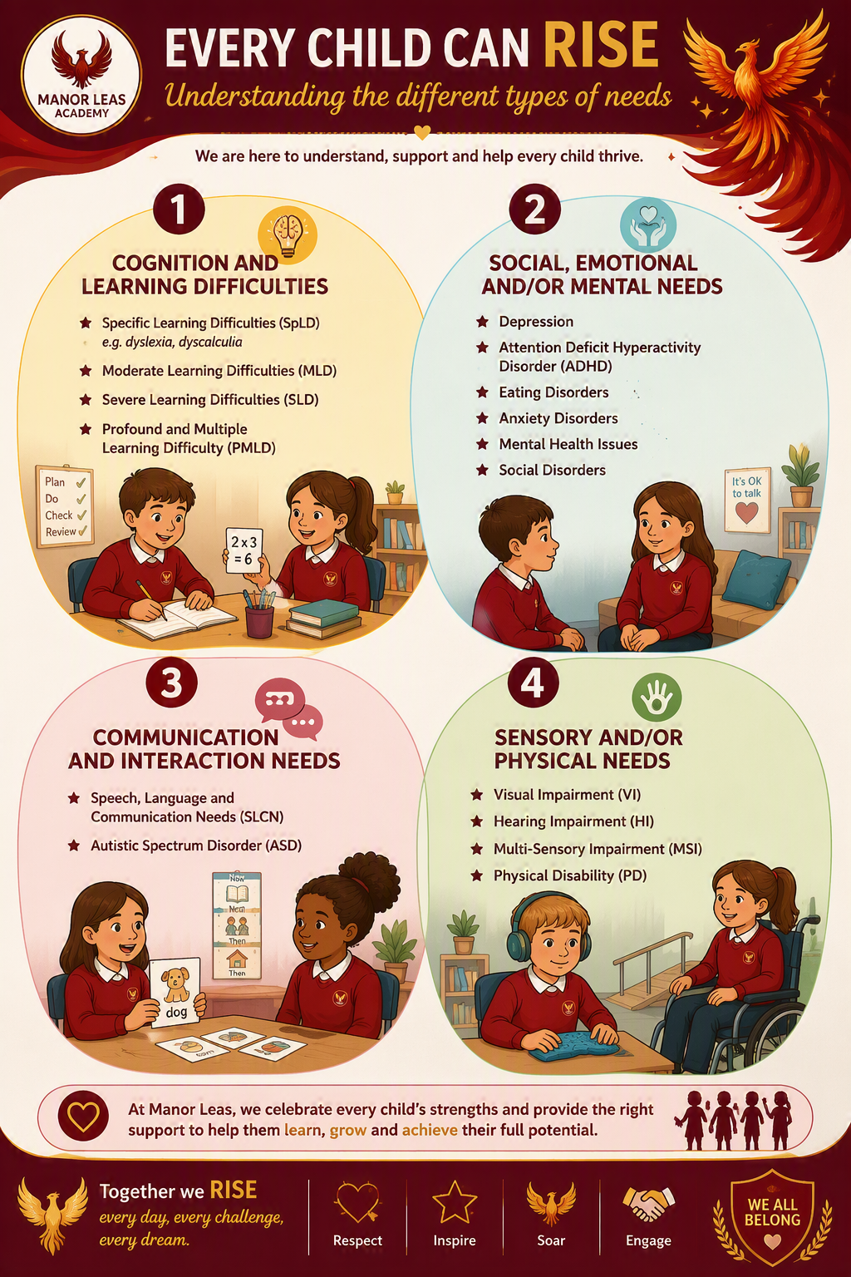
A child may have SEND if they experience difficulties which make learning harder than most children of the same age. The SEND Code of Practice identifies four broad areas of need.

How does the school identify and support SEND?

No single assessment identifies SEND. We work together to build a full picture of each child's strengths, needs and experiences before deciding on the most appropriate support.
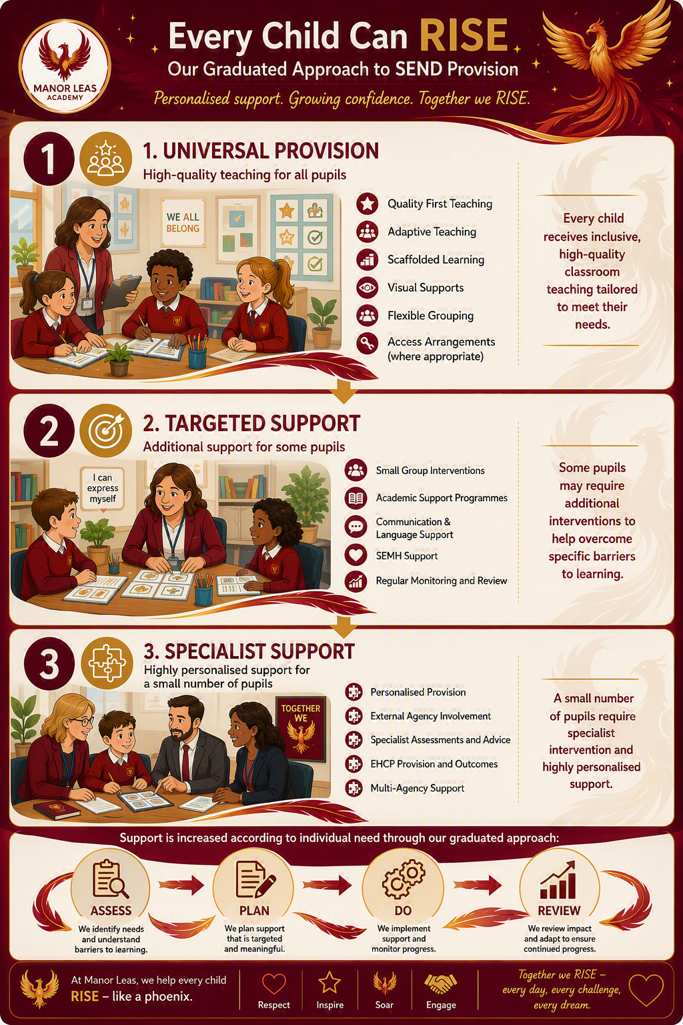
How does the school decide what support is needed?

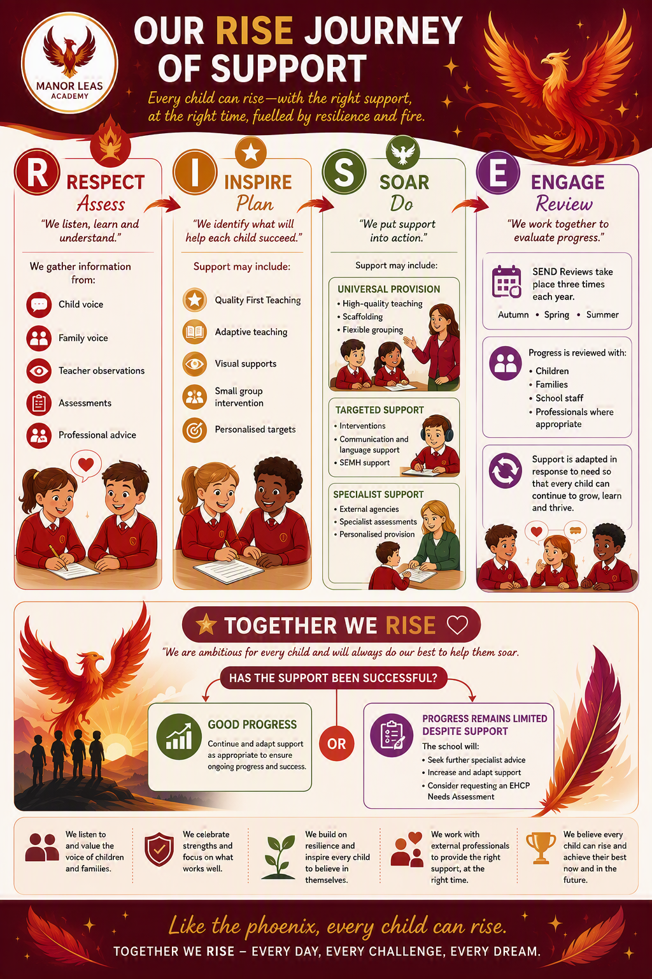

How We Help Every Child Soar
At Manor Leas Junior Academy, we believe that every child can rise, achieve and soar when they receive the right support, at the right time, in the right way. When a child needs additional support, we follow the Assess–Plan–Do–Review (APDR) cycle, a graduated approach that ensures support is carefully tailored to their individual strengths and needs. This process enables us to identify barriers to learning, celebrate successes and continually adapt provision so that every child can flourish.
Assess – We build a full picture of the child through assessment, observation, discussions with parents and carers, pupil voice, progress information and, where appropriate, advice from external professionals. We recognise that every child's journey is unique and seek to understand not only their areas of need but also their talents, interests and aspirations.
Plan – Working in partnership with parents, carers and the child, we agree achievable outcomes and identify the strategies, adjustments and support needed to help them succeed. Together, we create a clear pathway for progress that builds confidence, independence and resilience.
Do – The agreed support is implemented through high-quality teaching, adapted learning opportunities, targeted interventions and personalised strategies. Staff work collaboratively to ensure children can access the curriculum, participate fully in school life and experience success alongside their peers.
Review – Progress is reviewed regularly with pupils and families to evaluate the impact of support and agree next steps. Formal reviews typically take place termly, although support may be adapted sooner if needed. By listening to children and working closely with families, we ensure provision remains responsive, effective and focused on helping each child reach their potential.
Parents and carers are involved at every stage of the process because we believe that children achieve the very best outcomes when school and home work together. Through this cycle of assessment, support and review, we nurture self-belief, celebrate progress and help every child develop the confidence and skills they need to rise above challenges and soar towards their future.

Every Child Can Rise
At Manor Leas Junior Academy, we believe that every child rises with the right support, at the right time, fuelled by resilience and fire. We are committed to providing an ambitious, inclusive curriculum that enables every child to learn, achieve and belong. We recognise that children learn in different ways and may require different levels of support to access learning successfully. Our aim is to remove barriers, build confidence and help every child develop the skills they need to soar.
Adaptive Teaching
High-quality teaching is the foundation of support for all pupils. Teachers carefully adapt learning to meet the needs of individuals and groups within the classroom. This may include breaking learning into smaller steps, using visual supports, providing additional explanations and modelling, adapting questioning and using practical resources to support understanding. By responding to pupils' strengths and needs, we ensure that every child can engage meaningfully with learning and experience success.
Additional Support
Some children may require support that is additional to or different from that provided for their peers. This may include targeted interventions, small-group teaching, precision teaching, pre-teaching of key concepts, assistive technology or support from a Teaching Assistant. Any additional support is carefully planned, monitored and reviewed to ensure it has a positive impact on progress, confidence and independence.
Individual Targets
Where appropriate, pupils may have personalised targets linked to their individual needs. These targets are developed in partnership with pupils and families and help to identify clear next steps for learning, communication, independence, wellbeing or social development. Progress towards targets is reviewed regularly through the Assess–Plan–Do–Review process so that support can be adapted when needed.
Removing Barriers to Learning
We work hard to identify and reduce barriers that may affect a child's ability to learn, participate or achieve. This may involve reasonable adjustments, adapted resources, communication supports, sensory strategies, wellbeing support or environmental changes. We focus on understanding what helps each child to succeed and ensuring they have access to the tools and support they need to reach their potential.
Inclusive Access to the Curriculum
We believe that every child should have the opportunity to learn alongside their peers and participate fully in school life. Children with SEND are supported to access the full curriculum, educational visits, clubs, performances, sporting activities and wider enrichment opportunities. Inclusion is not simply about being present; it is about belonging, participating and experiencing success.
Together We RISE
At Manor Leas Junior Academy, we celebrate every child's unique strengths, talents and aspirations. Through adaptive teaching, personalised support and strong partnerships with families, we ensure that every learner is challenged, supported and empowered to achieve. By removing barriers and nurturing resilience, we help every child rise above challenges, believe in their potential and soar towards their future.

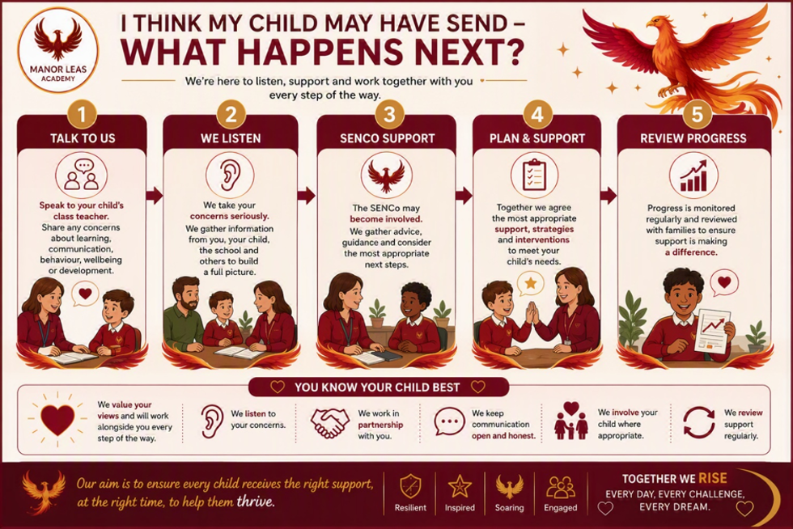

What Happens if My Child Needs More Support Than SEN Support?
Continuing to Help Every Child Soar
At Manor Leas Junior Academy, we are committed to ensuring that every child receives the right support, at the right time, to help them achieve their full potential. For most pupils, needs can be effectively met through high-quality teaching, adaptive practice and SEN Support. However, for a small number of children, additional or more specialist support may be required.
If, despite targeted support and regular reviews through the Assess–Plan–Do–Review process, a child continues to experience significant barriers to learning, we may seek advice from external professionals such as Educational Psychologists, Speech and Language Therapists, Specialist Teachers or health services. Working closely with families, we will consider whether further assessments are needed and discuss the most appropriate next steps.
In some circumstances, it may be appropriate to request an Education, Health and Care Needs Assessment (EHCNA) from the Local Authority. This process considers whether a child's educational needs require support beyond that which is ordinarily available through SEN Support. If an assessment identifies that additional provision is required, an Education, Health and Care Plan (EHCP) may be issued. An EHCP outlines a child's strengths, needs, outcomes and the support required to help them succeed.
Parents, carers and the child are involved throughout this process, and their views are central to any decisions that are made. We understand that this can feel daunting, and we are committed to providing guidance, reassurance and support every step of the way. Our goal remains the same: to work together to remove barriers, nurture resilience and ensure every child has the opportunity to rise, achieve and soar.

Who will support my child in school?
At Manor Leas Junior Academy, a range of people may work together to support your child's learning, wellbeing and development.

Who will support my child? | What do they do?
Class Teacher  Your child's first point of contact | ✓ Delivers high-quality classroom teaching.  ✓ Monitors your child's progress and wellbeing.  ✓ Adapts learning to meet individual needs.  ✓ Works closely with parents and carers to ensure the best outcomes.
SENCo (Special Educational Needs Coordinator) | ✓ Coordinates SEND provision across the school.  ✓ Supports staff in meeting pupils' needs.  ✓ Monitors the progress of pupils with SEND.  ✓ Works alongside families to plan support.  ✓ Liaises with external agencies and professionals.  ✓ Leads EHCP Annual Reviews.
Teaching Assistants (TAs) | ✓ Deliver targeted intervention programmes.  ✓ Provide support within the classroom.  ✓ Help pupils develop independence and confidence.  ✓ Support social, emotional and wellbeing needs.
External Professionals | Where appropriate, we may seek advice and support from:  • Educational Psychologists  • Speech and Language Therapists  • Specialist Teaching Service  • Healthy Minds  • Medical Professionals
Parents and Carers
An important part of the team
We believe parents know their child best and value regular communication and partnership working throughout the SEND process.
If concerns are identified, we will work closely with parents, carers and the child to build a clear picture of need. Additional assessments or observations may be completed, support will be agreed and reviewed regularly through the Assess–Plan–Do–Review cycle. Parents and carers will be involved throughout the process.

What if I Have a Concern?
We encourage parents and carers to speak to their child's Class Teacher in the first instance.
If concerns remain, please contact:
Rachael Simeoli (SENCo)
Chelsea Sandbrook (Headteacher)
Further information can be found in the school's Complaints Policy on the school website.
Once a concern is raised, we will listen carefully and work in partnership with you to understand your child's strengths and any barriers to learning. We may gather information through discussions, observations and assessments before agreeing the most appropriate support. Any support put in place will be reviewed regularly with you and your child to ensure it is making a positive difference. Where concerns are not evident within the school environment, we will work with you to explore possible reasons and, where appropriate, signpost you to services that may be able to offer support beyond school.

What training do staff have to support children with SEND?
Our Commitment
We are committed to ongoing professional development to ensure staff have the knowledge and skills required to support pupils with SEND effectively.
Recent Training Includes
- Adaptive Teaching
- Autism Awareness
- Speech and Language Approaches
- Sensory Circuits
- Emotional Wellbeing and SEMH
- Sound Linkage
- ELSA Training
- PIVATS Assessment
- Safeguarding
Specialist Training
Where specific pupil needs are identified, staff receive additional training and guidance from specialist agencies and professionals.

How will my child's wellbeing, voice and needs be supported?

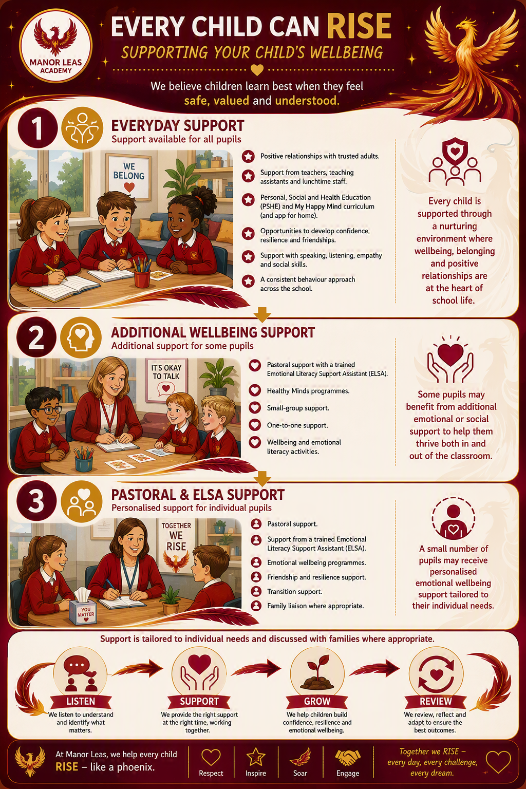
We are committed to supporting every child's wellbeing, safety and health needs so that they feel happy, secure and ready to learn. We work in partnership with families to ensure children receive the right support at the right time and are able to thrive both socially and emotionally.
How will school support my child's medical needs?

If your child has a medical condition, we will work closely with you to ensure appropriate support is in place.
This may include:
- Individual Healthcare Plans.
- Staff awareness and training.
- Administration of medication.
- Adaptations to support access and participation.
- Ongoing communication with families and healthcare professionals.
If your child requires medication during the school day, please contact the school office.

How do we make school accessible for every child?
We want every child to be able to access all areas of school life.
Our school includes:
- Accessible entrances and ramp access where required.
- Lift access to the upper floor.
- A hygiene suite.
- Access to ICT and assistive technology where appropriate.
- Adaptations and reasonable adjustments to meet individual needs.
We continually review our environment to ensure that children with SEND can access learning and school facilities successfully.

Will my child be included and supported at school?
Every Voice Matters
At Manor Leas Junior Academy, we believe that every child rises with the right support, at the right time, fuelled by resilience and fire. We know that children are experts in their own experiences, and their views are an essential part of helping them achieve success. By listening to our pupils, valuing their perspectives and involving them in decisions about their learning, we empower them to develop confidence, independence and self-belief.
Sharing Their Views
Children are encouraged to share their thoughts, feelings and aspirations in ways that are appropriate to their age and stage of development. We talk regularly with pupils about what is working well, what they find challenging and how we can support them to achieve their goals. Whether through conversations with trusted adults, pupil discussions, review meetings, surveys or classroom activities, we make sure every child has opportunities to be heard.
Pupil Involvement in Reviews
Pupils are actively involved in reviewing their progress and celebrating their achievements. As part of the Assess–Plan–Do–Review cycle, children are encouraged to reflect on their learning, identify what has helped them succeed and share their ideas for future support. Their views are considered alongside the perspectives of parents, carers and staff when planning next steps and setting new targets. This helps children to understand their own learning journey and develop the skills to become confident and independent learners.
Annual Reviews for Pupils with EHCPs
For pupils with an Education, Health and Care Plan (EHCP), their voice is a central part of the Annual Review process. Children are supported to contribute in ways that feel comfortable and meaningful to them, sharing their achievements, aspirations, interests and views about the support they receive. We believe that every child should play an active role in shaping their future, and we ensure that their contributions help inform decisions about outcomes, provision and next steps.
Listening Throughout the Year
Listening to children is not limited to formal meetings. Throughout the school year, staff gather ongoing feedback through daily interactions, observations, intervention sessions and wellbeing conversations. These regular opportunities allow us to respond quickly to emerging needs, celebrate successes and ensure that support remains relevant and effective. By continually seeking and valuing pupil feedback, we strengthen relationships, build trust and create an environment where every child feels respected, included and understood.
At Manor Leas Junior Academy, we are committed to ensuring that every child knows their voice matters. By working together with pupils, families and staff, we create a culture where children are empowered to overcome challenges, believe in their potential and soar towards a bright and successful future.


How will I know how my child is doing?
We value open and honest communication with families. We will work alongside you to celebrate successes, address concerns and ensure your child receives the support they need to thrive.

Supporting Learning at Home
Learning Together, Growing Together
At Manor Leas Junior Academy, we recognise that parents and carers play a vital role in their child's learning journey. We believe that children achieve the best outcomes when school and home work together in partnership. By sharing strategies, celebrating successes and providing practical guidance, we help families support learning in ways that are manageable, positive and effective.
Reading regularly at home is one of the most valuable ways to support your child's progress. We encourage families to enjoy books together, discuss characters and events, ask questions about what has been read and celebrate a love of reading. Staff may also recommend specific strategies or resources to help develop fluency, comprehension and confidence.
Children can also benefit from practising key mathematical skills through games, problem-solving activities and real-life experiences such as shopping, cooking, measuring and telling the time. Learning through everyday activities helps children apply their knowledge and build confidence in a meaningful way.
Where appropriate, we may recommend useful websites, online resources, apps or practical activities that support your child's individual learning needs. Families may also receive advice from external professionals, such as Speech and Language Therapists, Educational Psychologists or Specialist Teachers, which can be incorporated into daily routines at home.
We value open and regular communication between home and school. Through Class Dojo, emails, telephone conversations, meetings and review discussions, we work together to celebrate achievements, address concerns and ensure that support remains effective. If you are unsure how best to support your child at home, please speak to your child's Class Teacher or the SEND Team, who will be happy to offer advice and guidance.
Together, we can nurture confidence, resilience and a love of learning, helping every child to rise, achieve and soar.

How will my child be included in clubs, trips and wider school life?

We believe every child should be able to learn, participate and achieve alongside their peers. We work hard to remove barriers so that every child can thrive.

How will you support transitions and moving on?
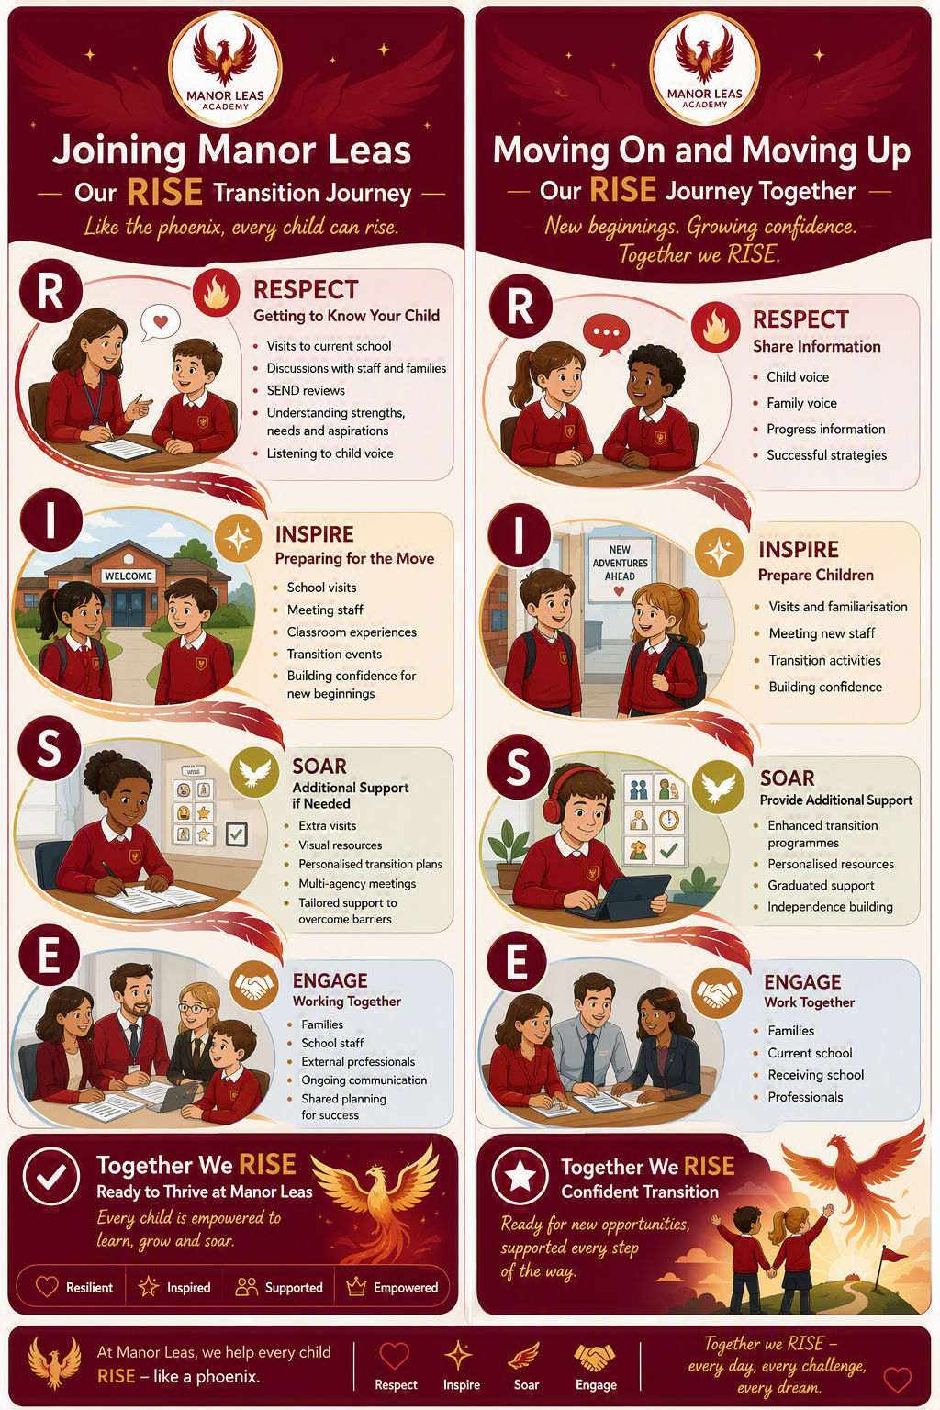
Where can my family access additional help and support?
At Manor Leas Junior Academy, we understand that families sometimes need support beyond school. The services below offer information, advice and practical support for children, young people and their families across Lincolnshire.
Together We RISE
We believe every child can rise, achieve and thrive. If you are unsure where to start, please contact the Manor Leas SEND Team and we will be happy to help you access the right support at the right time.

Service | How They Can Help | Contact Details
Lincolnshire SENDIASS (Liaise) | Free, confidential and impartial SEND information, advice and support. Help with SEND support, EHCPs, Annual Reviews and understanding your rights. | Tel: 0800 195 1635  Web: www.liaiselincolnshire.org.uk
FamilyLine (Family Action) | Emotional support, parenting advice, family relationships, caring responsibilities and practical guidance. | Tel: 0808 802 6666  Text: 07537 404282  Web: family-action.org.uk/get-support/familyline
Here4You | Mental health and emotional wellbeing advice line for children, young people, parents and professionals. | Tel: 0800 234 6342
Healthy Minds Lincolnshire | Early emotional wellbeing support, anxiety support, self-esteem support and online workshops for children and families. | Web: www.lpft.nhs.uk/young-people/online-workshops
Working Together Team (WTT) | Specialist autism and neurodiversity support, parent workshops and transition support. | Tel: 01775 840250  Web: www.wtt.org.uk
Lumi Nova: Tales of Courage | Free therapeutic app helping children aged 7–12 build resilience and manage worries and anxiety. | Web: luminova.app/lincolnshire
The Sleep Charity | Advice and support for children experiencing sleep difficulties, including children with SEND. | Web: www.thesleepcharity.org.uk
Children's Continence Service | Advice and support for children experiencing bladder and bowel difficulties. | Tel: 01522 843000
Lincolnshire SEND Local Offer | Information about SEND services, support, activities and resources across Lincolnshire. | Web: www.lincolnshire.gov.uk/send-local-offer
ERIC | National charity supporting children and young people with bladder and bowel difficulties. | Web: www.eric.org.uk
YoungMinds | Mental health information, advice and resources for parents and young people. | Web: www.youngminds.org.uk

